RIPHAH INTERNATIONAL UNIVERSITY


Faculty of Computing
Object Oriented Programming Lab
Lab 6
Aggregation and Composition
Submitted By: Khadija Binte Asif
SAP ID:77954
Submitted To: Miss Nayab Khalid
Lab Manual Development Team

Supervision and Coordination

Hira Jaffar
Lecturer
Faculty of Computing

Lab Designers
Nayab Khalid Kayani
Lecturer
Faculty of Computing

Lab Exercise

Task 1:
A Team has many Players, but each Player can exist without the Team (he can join another team).
- Create a Player class with jerseyNo and name.
- Create a Team class with a list of Players.
- Deleting the Team must NOT delete the Players.
- In main, create some Players, add them to the Team, and display them.

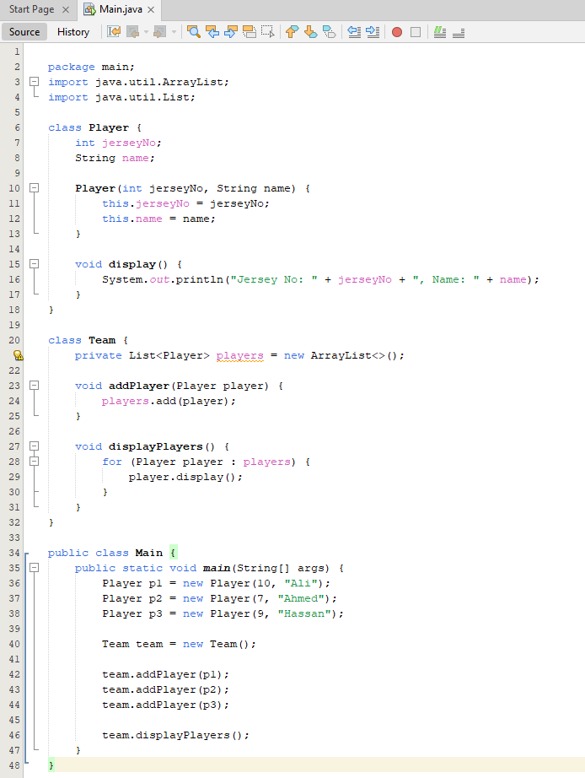

Output:
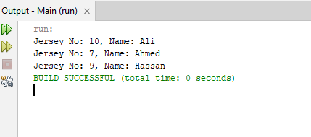

Task 2:
A Car has an Engine. The Engine is built inside the Car and cannot exist without it.
- Create an Engine class with a start() method that prints a message.
- Create a Car class that makes its own Engine inside the constructor.
- In main, create a Car and call drive(), which starts the Engine.

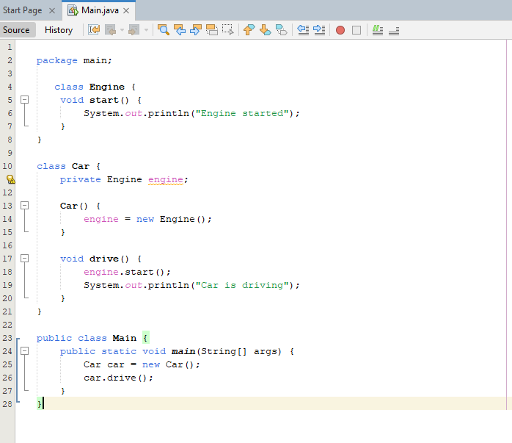
Output:


